SENG 696 Report 1: University Student Registration Agents
Ayah Metwali, 30042982

This report will be in the order below:
- System Specifications (Pg. 2)
- Business Case, pg. 2
- System Description, pg. 2
- Assumptions, pg. 3
- Requirements, pg. 4
- Wish List (Not Implemented) pg. 4

- Design Document (GAIA Methodology) (Pg 5)
- Requirements Statement pg. 5
- Goal Identification pg. 5
- Analysis Phase pg. 6
  - Role Model pg. 6
  - Interaction Model pg. 10
- Design Phase pg. 11
  - Agent Model pg. 11
  - Service Model pg. 11
  - Acquaintance Model pg. 12
- Agent Description pg. 13
- Agent Internal Architecture pg. 15
- Extensions and Limitations (Preliminary) pg. 15

- System Specifications:
- Business Case
University course registration is a recurring process that competes on two constrained recourses at once: seats in individual sections and the finite time slots in a student’s own schedule. Students must follow degree requirements, prerequisite chains, and section availability across multiple departments, often within a narrow registration window.

Existing registration systems acts as record keepers where they display seat counts and let a student attempt an enrollment, but the burden of checking for time conflicts, verifying prerequisites, and monitoring waitlists across several departments falls on the student/ As course catalogues grow and popular sections fill within minutes of opening, this manual coordination becomes error-prone and time-consuming.

A multi-agent approach can assist in this problem because the underlying task is distributed where each department controls its own section data and enrollment rules, while the students’ overall schedule is separate. Modelling departmental course data and the scheduling logic as autonomous, cooperating agents allows each concern to be owned by the agent best positioned to reason about it, while a coordinating agent assembles the results into one recommendation for the student.

- System Description
We will be calling this system as the university course registration and scheduling assistant (UCRSA). It is a multi-agent system that helps a student assemble a conflict-free, prerequisite satifying course schedule by coordinating a Registration Assistant Agent, a Scheduler Agent, a set of department level Course Agents, and a Registrar Agent.

The student interacts with a single Registration Assistant Agent through a browser-based interface. This agent collects the student’s course preferences, consults the Scheduler Agent to check the proposed selection against the student’s existing schedule and degree requirements, queries the relevant Course Agents for section availability, and once the student approves a schedule, submits it to the Registrar Agent to be finalized.

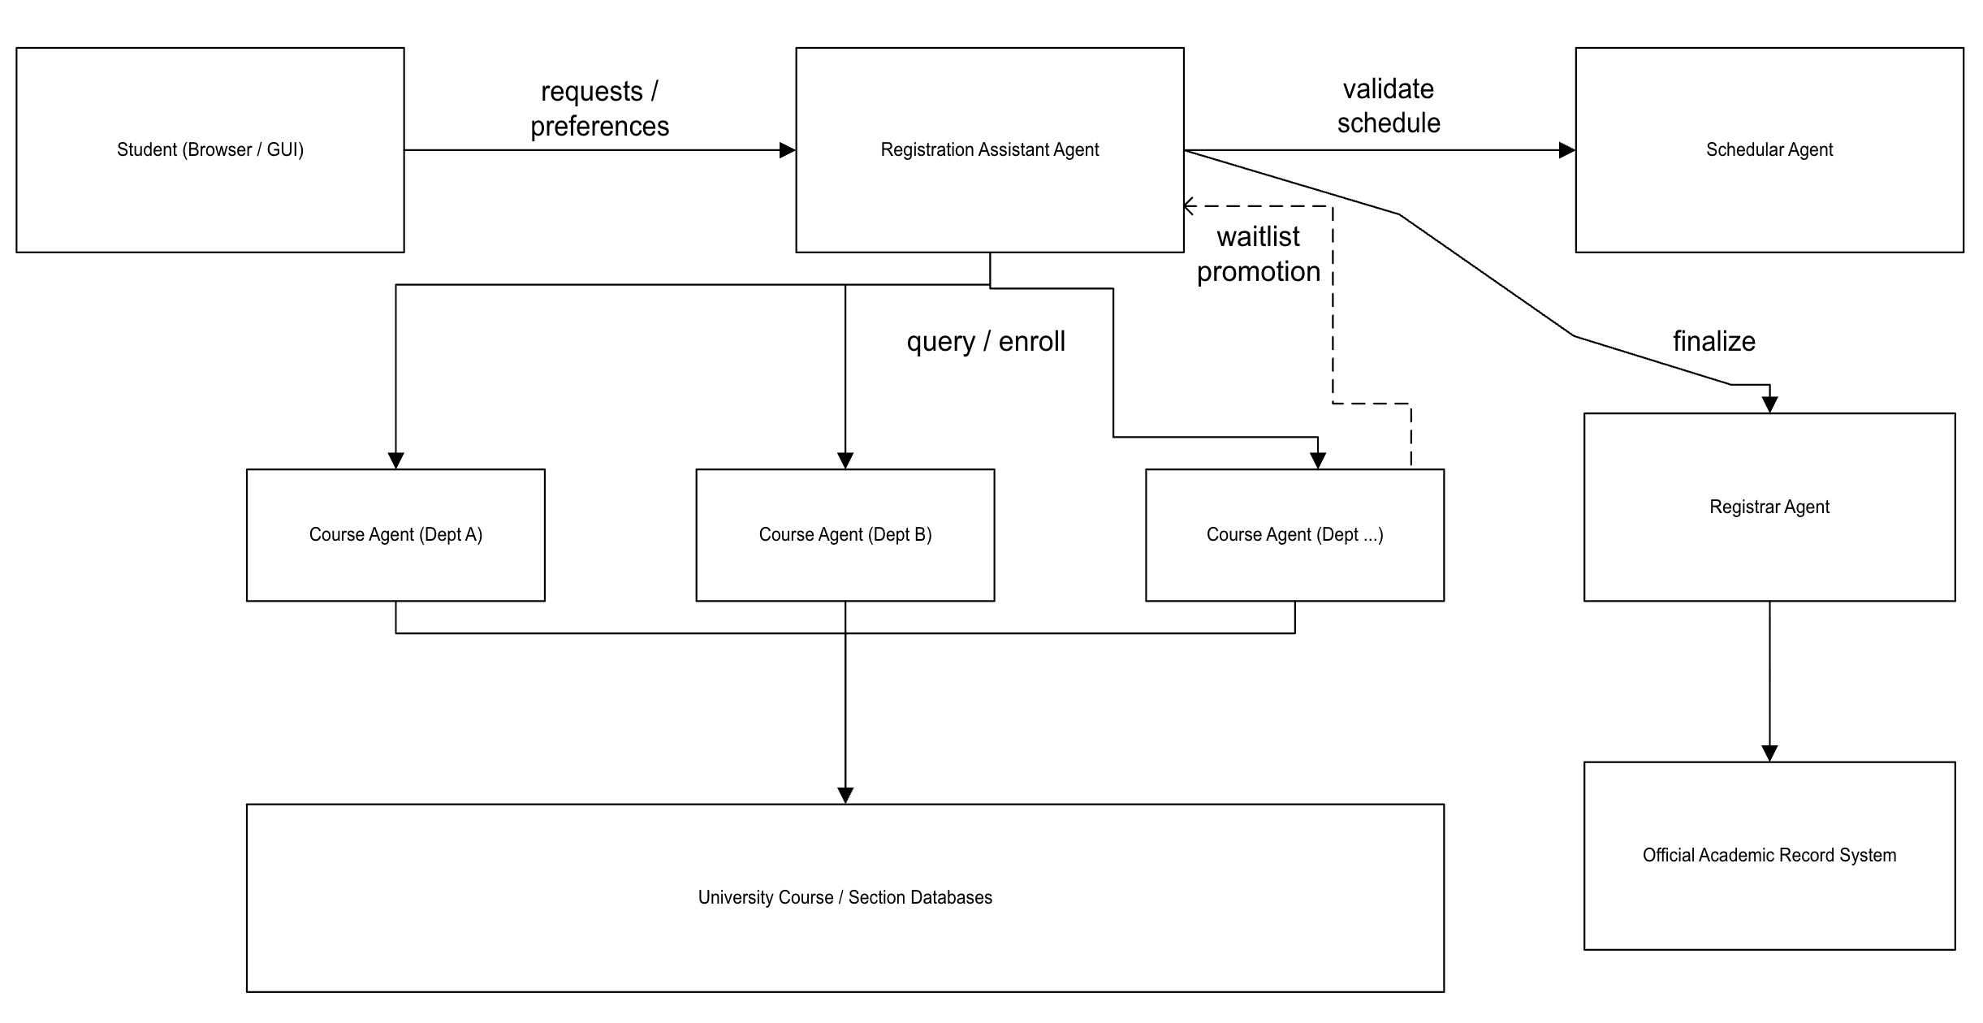

- Assumptions
  - Each student has an existing profile that records their declared program, completed course history, and degree requirements.
  - The student specifies desired courses, acceptable time windows, and a maximum course load through the browser interface. Recurring preferences (e.g., no classes before 9:00 AM) may also be stored in the student profile in advance.
  - Course, prerequisite, and seat-availability data are already exposed to UCRSA through a standardized interface agreed by all departments (as in every Course Agent shares a common message schema for course codes, prerequisites, and seat counts).
  - Enrollment and waitlist transactions are small at the section level. A single request either succeeds, is queued on a waitlist, or fails outright.
  - A student’s schedule may be finalized with some courses enrolled and others waitlisted. UCRSA does not require every requested course to succeed before registration and proceed.
  - The Registrar Agent holds a student’s official registration record.

- Requirements
  - UCRSA will:
    - Provide course and section inquiries, including seat availability, meeting times, and prerequisites, across multiple departments.
    - Query multiple department Course Agents to source candidate sections for a requested course.
    - Verify a proposed schedule against the student’s existing enrollments to detect time conflicts before any enrollment request is submitted.
    - Verify that prerequisite requirements are satisfied before allowing an enrollment request to proceed.
    - Enroll the student in a section or place the student on that section’s waitlist if no seats remain, up to the student’s approval.
    - Notify the student of any change to their registration status, including a move off a waitlist or a conflict discovered after an initial request.
    - Monitor current waitlist requests and attempt enrollment automatically when a seat becomes available.

- Wish List (Not Implemented)
  - Allow the student to run “what if” schedule simulations without committing to a registration transaction.
  - Support negotiated section swaps directly between two students.
  - Detect an alert the student to list-minute section changes such as a room, time, or instructor change.
  - Allow Course Agents to register themselves dynamically with UCRSA through a discovery service as departments add new offerings (rather than being statically made).

- Design Document
This design will follow the GAIA methodology.
- Requirements Statement (repeated from the first section, stated again below):
  - Provide course and section inquiries including seat availability, meeting times, and prerequisites, across multiple departments.
  - Query multiple department Course Agents to source candidate sections for a requested course.
  - Verify a proposed schedule against the student’s existing enrollments to detect time conflicts before any enrollment request is submitted.
  - Verify that prerequisite requirements are satisfied before allowing an enrollment request to proceed.
  - Enroll the student in a section or place the student on that section’s waitlist if no seats remain, up to student’s approval.
  - Notify the student of any change to their registration status, including a move off a waitlist or a conflict discovered after an initial request.
  - Monitor standing waitlist requests and attempt enrollment automatically when a seat becomes available.

- Goal identification
The goal of UCRSA is a schedule that is conflict free, prerequisite satisfying, and preference aligned with a waitlist position counting as a valid partial outcome where a seat isn’t yet available. All working simultaneously.
With sub goals being:
  - Identify candidate sections that satisfy the student’s requested courses.
  - Verify that prerequisites for each candidate section are met.
  - Detect and resolve time conflicts between candidate sections and te student’s existing schedule.
  - Secure a seat or a waitlist position, for each approved section.
  - Finalize the registration transaction and record it in the official academic record.
  - Notify the student of any subsequent change in registration status.

- Analysis Phase
Role Model: Each agent will have hard and soft roles. The table below summarizes the allocation.
Agent | Hard Role(s) | Soft Role(s)
RegistrationAssistant Agent | PersonalAssistant | PreferenceAdvisor
SchedulerAgent | Scheduler | WorkloadAdvisor
CourseAgent (× one per department) | CourseProvider, WaitlistMonitor | DemandForecaster
RegistrarAgent | Registrar | ComplianceAuditor

The following are the schemas for the roles underneath each agent:
Role Schema |  |  | PersonalAssistant (hard)
Description |  |  | Acts on behalf of the student. Collects the student's course preferences, coordinates with the Scheduler and Course roles to assemble a candidate schedule, presents it to the student, and submits the approved schedule to the Registrar role.
Protocols / Activities |  |  | RequestSchedule, CollectSections, ProposeSchedule, ConfirmRegistration
Permissions |  |  | reads StudentProfile; reads DegreeRequirements; generates ProposedSchedule
Responsibilities: |  | Liveness | PERSONALASSISTANT = (RequestSchedule . CollectSections . ProposeSchedule . ConfirmRegistration) - repeats
 | Safety |  | A proposed schedule is never submitted to the Registrar role unless it has first been reported conflict-free by the Scheduler role.

Role Schema |  |  | PreferenceAdvisor (soft)
Description |  |  | Ranks the set of valid candidate schedules already cleared by the Scheduler role, according to the student's stated preferences (e.g., avoid early mornings, minimize gaps). Does not affect whether a schedule is valid, only the order in which valid schedules are presented.
Protocols / Activities |  |  | RankCandidates
Permissions |  |  | reads ValidatedScheduleSet; reads StudentPreferences; generates RankedScheduleList
Responsibilities: |  | Liveness | PREFERENCEADVISOR = (RankCandidates) - repeats
 | Safety |  | A schedule is never added to the ranked list unless it already appears in the validated candidate set produced by the Scheduler role.

Role Schema |  |  | Scheduler (hard)
Description |  |  | Validates a proposed set of course sections against the student's existing schedule and degree requirements. Detects time conflicts and unmet prerequisites before an enrollment request is allowed to proceed.
Protocols / Activities |  |  | CheckConflicts, CheckPrerequisites, ReportValidation
Permissions |  |  | reads StudentSchedule; reads StudentTranscript; reads DegreeRequirements
Responsibilities: |  | Liveness | SCHEDULER = (CheckConflicts . CheckPrerequisites . ReportValidation) - repeats
 | Safety |  | A validation report is never marked “clear” while an unresolved time conflict or an unmet prerequisite remains in the proposed set.

Role Schema |  |  | WorkloadAdvisor (soft)
Description |  |  | Reviews an already-validated schedule's total course load and flags an unusually heavy combination (e.g., several historically high-workload courses in the same term), without blocking registration.
Protocols / Activities |  |  | AssessWorkload
Permissions |  |  | reads ValidatedSchedule; reads CourseWorkloadRatings; generates WorkloadAdvisory
Responsibilities: |  | Liveness | WORKLOADADVISOR = (AssessWorkload) - repeats
 | Safety |  | A workload advisory is never generated for a schedule that the Scheduler role has not already validated as conflict-free.

Role Schema |  |  | CourseProvider (hard)
Description |  |  | Owns a single department's course and section data. Reports seat availability and prerequisite metadata, and processes enrollment and waitlist requests for its own sections. One instance exists per department.
Protocols / Activities |  |  | QuerySections, RequestEnrollment, RequestWaitlist, ReportSeatChange
Permissions |  |  | reads CourseCatalog; changes SeatCount; changes WaitlistQueue
Responsibilities: |  | Liveness | COURSEPROVIDER = (QuerySections . (RequestEnrollment or RequestWaitlist)) - repeats
 | Safety |  | SeatCount is never decremented below zero; a student already enrolled in a section is never added to that same section's waitlist.

Role Schema |  |  | WaitlistMonitor (hard)
Description |  |  | Periodically checks each section's waitlist against freed seats and promotes the next eligible student, notifying the PersonalAssistant role of the promotion. Unlike CourseProvider, this role runs proactively rather than in response to a single incoming request.
Protocols / Activities |  |  | CheckSeatAvailability, PromoteFromWaitlist
Permissions |  |  | reads WaitlistQueue; changes SeatCount; changes WaitlistQueue
Responsibilities: |  | Liveness | WAITLISTMONITOR = (CheckSeatAvailability . PromoteFromWaitlist - optional) - repeats
 | Safety |  | A student is never promoted out of waitlist order; a promotion is never issued for a section with no free seat.

Role Schema |  |  | DemandForecaster (soft)
Description |  |  | Tracks enrollment and waitlist growth for a department's sections over time and flags a section trending toward sustained oversubscription, as input to the department's own decision to open a new section. Produces no student-facing output.
Protocols / Activities |  |  | TrackDemandTrend
Permissions |  |  | reads EnrollmentHistory; reads WaitlistQueue; generates DemandAlert
Responsibilities: |  | Liveness | DEMANDFORECASTER = (TrackDemandTrend) - repeats
 | Safety |  | A demand alert never modifies SeatCount or WaitlistQueue directly; it is advisory only.

Role Schema |  |  | Registrar (hard)
Description |  |  | Holds the authoritative academic record. Finalizes registration transactions that have already been approved by the student and cleared by the Scheduler role, and issues official confirmation.
Protocols / Activities |  |  | FinalizeRegistration, IssueConfirmation
Permissions |  |  | changes OfficialRegistrationRecord
Responsibilities: |  | Liveness | REGISTRAR = (FinalizeRegistration . IssueConfirmation) - repeats
 | Safety |  | A registration is never finalized for a section that the Scheduler role has not reported as conflict-free and prerequisite-satisfying.

Role Schema |  |  | ComplianceAuditor (soft)
Description |  |  | Logs every finalized registration transaction against university policy checks (e.g., credit load limits) for audit purposes, without altering the transaction itself.
Protocols / Activities |  |  | LogRegistrationEvent
Permissions |  |  | reads OfficialRegistrationRecord; generates AuditLogEntry
Responsibilities: |  | Liveness | COMPLIANCEAUDITOR = (LogRegistrationEvent) - repeats
 | Safety |  | An audit log entry is never created before the Registrar role has finalized the corresponding transaction; an audit log entry never modifies OfficialRegistrationRecord.

- Interaction Model
Soft roles that only use data already held by their own agent (PreferenceAdvisor, WorkloadAdvisor, DemandForecaster, ComplianceAuditor) do not introduce new inter-agent protocols; WaitlistMonitor is the exception, since a promotion must be reported back to the student.
Protocol | Initiator | Responder | Inputs | Outputs | Processing
RequestSchedule | Student | PersonalAssistant | Desired courses, time preferences | Acknowledgement | Store preferences for the session
CheckConflicts | PersonalAssistant | Scheduler | Candidate section list, existing schedule | Conflict report | Compare section meeting times pairwise
CheckPrerequisites | PersonalAssistant | Scheduler | Candidate section list, transcript | Prerequisite report | Compare completed courses against requirements
QuerySections | PersonalAssistant | CourseProvider | Course code | Section list with seat counts | Filter by term and status
RequestEnrollment | PersonalAssistant | CourseProvider | Student ID, section ID | Enrollment confirmation or waitlist position | Decrement seat count or queue request
FinalizeRegistration | PersonalAssistant | Registrar | Approved section list, validation report | Confirmation number | Write to official record
PromoteFromWaitlist | WaitlistMonitor | PersonalAssistant | Section ID, promoted student ID | Promotion notice | Update session state; notify student

- Design Phase
Agent Model:

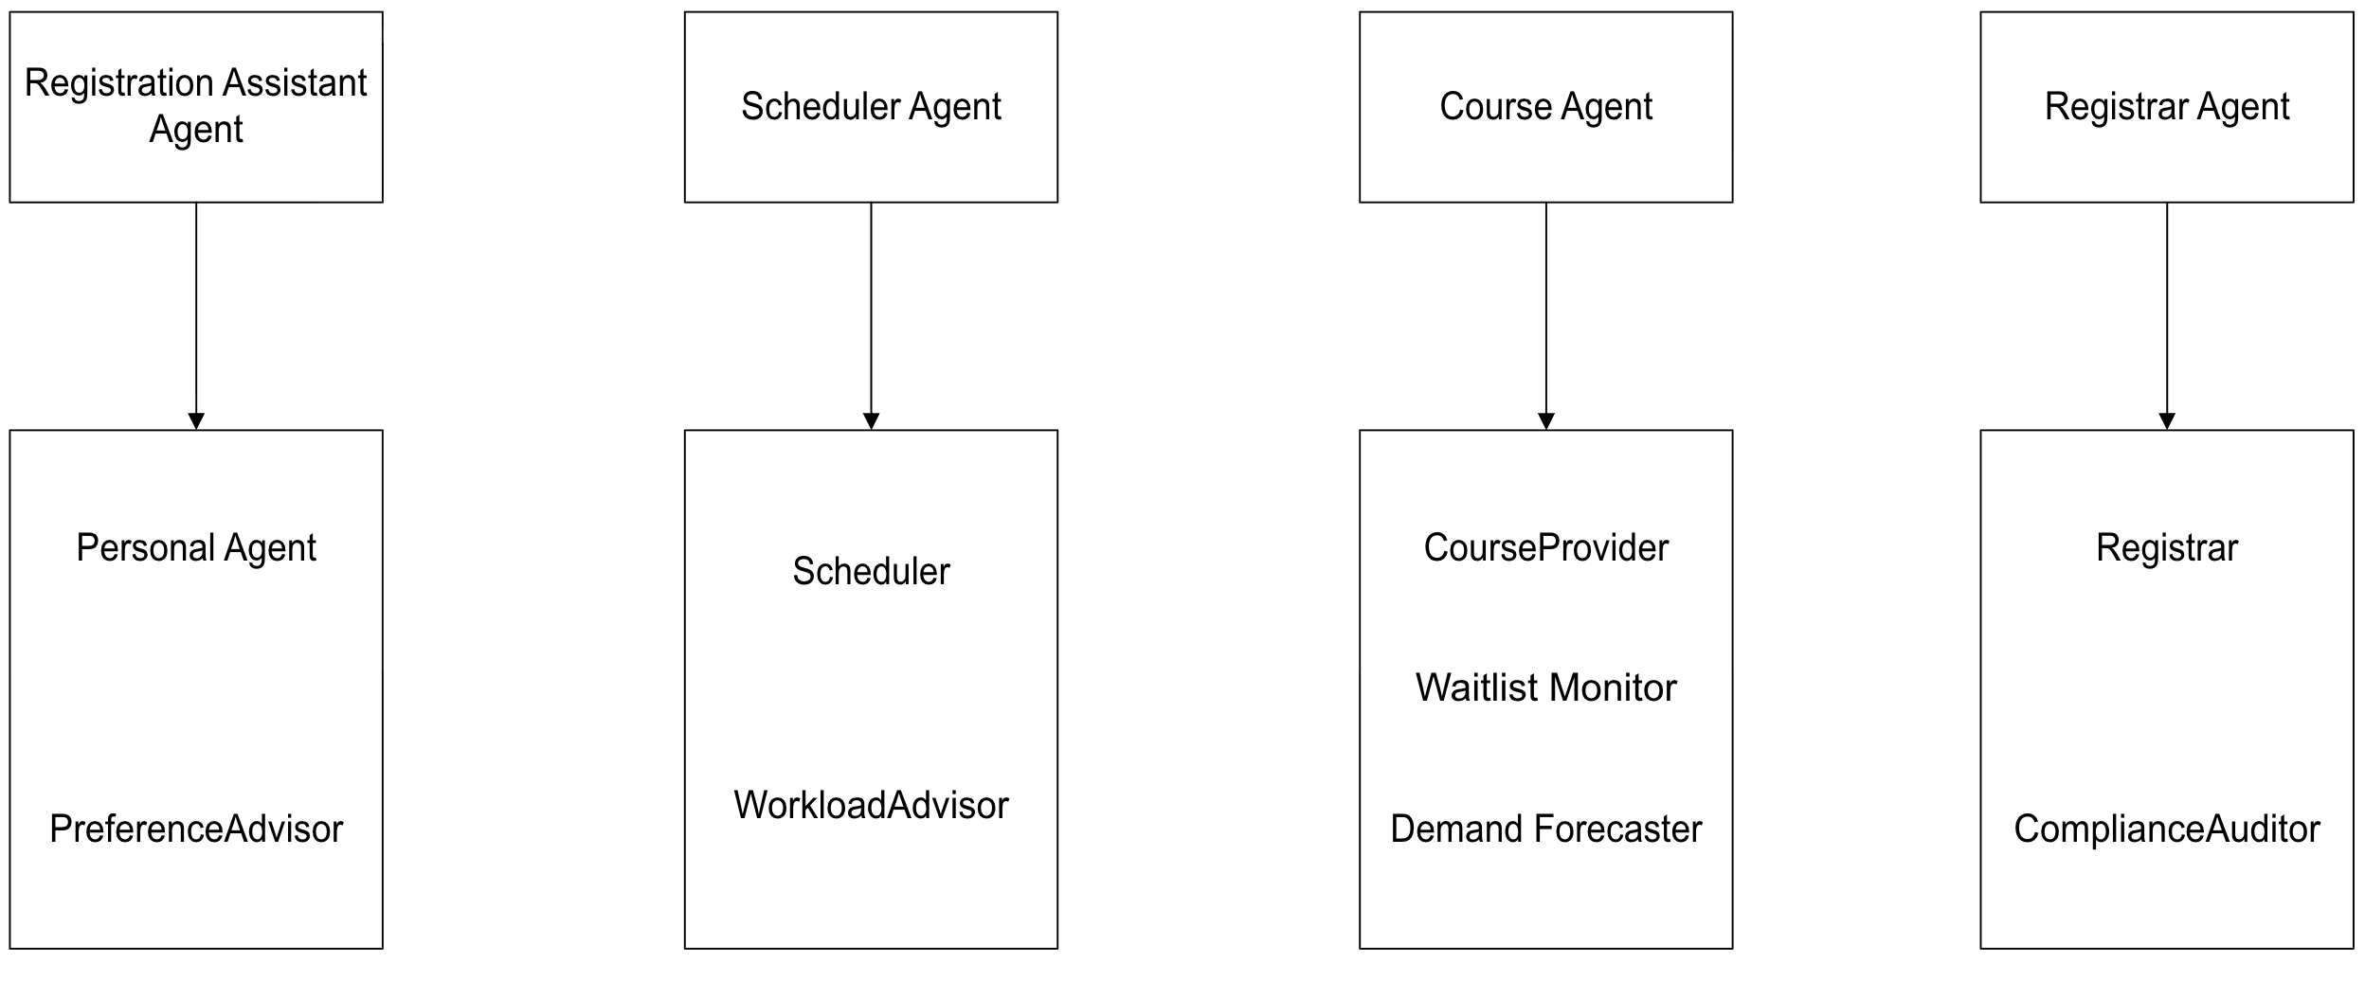
Service Model:
Service | Inputs | Outputs | Pre-conditions | Post-conditions
ValidateSchedule (Scheduler) | Candidate section list, student schedule, transcript | Validation report (clear, or list of conflicts/unmet prerequisites) | Student profile and transcript exist | Report is available to the Registration Assistant Agent
RankCandidates (PreferenceAdvisor) | Validated schedule set, student preferences | Ranked schedule list | Scheduler has validated at least one candidate | Ranked list is available to PersonalAssistant
AssessWorkload (WorkloadAdvisor) | Validated schedule | Workload advisory (optional) | Schedule already validated as conflict-free | None; advisory only
QuerySeats (CourseProvider) | Course code, term | Section list with seat counts and prerequisites | Course exists in the department catalogue | None
RequestEnrollment (CourseProvider) | Student ID, section ID | Enrollment confirmation or waitlist position | Validation report is clear for this section | Seat count decremented, or waitlist queue updated
PromoteFromWaitlist (WaitlistMonitor) | Section ID | Promotion notice | A seat has freed and the waitlist is non-empty | Seat count decremented; waitlist queue updated
TrackDemandTrend (DemandForecaster) | Enrollment history, waitlist queue | Demand alert (optional) | None | None; advisory only
FinalizeRegistration (Registrar) | Approved section list, validation report | Official confirmation number | All sections in the list are enrolled or waitlisted and validation is clear | Official academic record updated
LogRegistrationEvent (ComplianceAuditor) | Finalized registration record | Audit log entry | Registrar has finalized the transaction | Audit log updated; record itself unchanged

Acquaintance Model:
The Registration Assistant Agent is the only agent type that communicates directly with the student, and every other agent conversation passes through it. It is the initiator in all but one case where the exception is the CourseAgent’s WaitlistMonitor role, which initiates PromoteFromWaitlist back to the Registration Assistant Agent when a seat frees up.
- RegistrationAssistant speaks to the Scheduler Agent (requests schedule validation)
- RegistrationAssistant speaks to the CourseAgent (queries sections, submits enrollment/waitlist requests).
- RegistrationAssistant speaks to the RegistrarAgent (submits the approved schedule for finalization)
- CourseAgent speaks to RegistrationAssistant (WaitlistMonitor reports a waitlist promotion).

- Agent Description:
Agent - Registration Assistant Agent
Roles: PersonalAssistant (hard), PreferenceAdvisor (soft).
The Registration Assistant Agent is the student facing communicator of the system. Through the PersonalAssistant role it collects the student’s desired courses and preferences through the browser interface, requests validation from the Schedule Agent, queries the relevant Course Agents for section options, and shows a consolidated set of choices back to the student. Once the student approves the selection, it submits the schedule to the Registrar Agent and relays the resulting confirmation or any later status change (including a WaitlistMonitor promotion) back to the student. Through the PreferenceAdvisor role it orders the validated candidates it receives so the student’s likely best fit is shown first.

Agent: Scheduler Agent
Roles: Scheduler (hard), WorkloadAdvisor (soft)
The Scheduler Agent is responsible for validating any schedule proposed by the Registration Assistant Agent. Through the Scheduler role, it checks the proposed sections against the student’s existing enrollments for time conflicts and against the student’s transcript for missing prerequisites and returns a validation report that the Registration Assistant Agent must receive as “clear” before any enrollment request may proceed. Through the WorkloadAdvisor role, it attaches an optional advisory when an already valid schedule looks unusually heavy.

Agent: Course Agent
Roles: CourseProvider (hard), WaitlistMonitor (hard), DemandForecaster (soft)
Course Agent represents a single department’s couse and section data, one instance exists per department. Through the CourseProvider role, it responds to queries about seat availability, meeting times, and prerequisites, and processes enrolment and waitlist requests directed at its sections. Through the WaitlistMonitor role, it constantly watches its own waitlists and promotes the next eligible student when a seat frees up, notifying the Registration Assistant Agent directly rather than waiting to be asked. Through the DemandForecaster role, it tracks enrollment trends for its own department’s use, with no effect on student facing behaviour.
Agent: Registrar Agent
Roles: Registrar (hard), ComplianceAuditor (soft)
The Registrar Agent holds the university’s official registration record. Through its Registrar role, it accepts only schedules that have already been approved by the student and cleared by the Scheduler Agent, finalizes the enrollment and waitlist selections, and issues an official confirmation number hack to the Registration Assistant Agent. Through the ComplianceAuditor role it records an audit log entry for every finalized transaction without altering the transaction itself.

Agent Internal Architecture
- Listener: Listens on the agent’s message port for incoming requests from other agents or in the case of the Registration Assistant Agent, from the student’s browser session.
- Interpreter: Parses incoming messages against the shared course/schedule message schema agreed upon by all agent types. So that a course code, section ID, or student ID means the same thing to every agent that reads it.
- Processor: Holds one internal handler per role the agent plays (e.g., the Course Agent’s Processor holds a CourseProvider handler, a WaitlistMonitor handler, and a DemandForecaster handler), and uses the Interpreter’s output (or internal timer for WaitlistMonitor) to get the correct handler and produce a result.
- Local store: The agent’s own data such as a Course Agent’s section table or the Scheduler Agent’s view of a student’s schedule.
- Responder: Formats the Processor’s result back into the shared message schema and returns it to the requesting agent or initiates a new outgoing message.

Extensions and Limitations (Preliminary)
- The central coordinator model has most of the coordination in the Registration assistant Agent which the load itself could become a bottleneck. A future iteration might address by allowing Course Aegnts to communicate seat changes directly to a shared waitlist-monitoring service.

